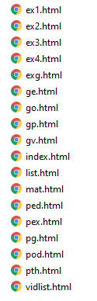
New Grammar Website April 2020

What is on this site
First, this site is intended for Italians wanting to speak English, so there will be some videos and texts in Italian.
Here you can find all the information necessary to begin to understand how the English language is used today.
There are all the Grammar Points you need to get to grips with the rules, structures and syntax of English as well as Grammar Videos (in Italian) of all the Grammar Points so that you can understand what the points mean.
Pronunciation is always a problem. Here there is Video and Audio material for some basic pronunciation.
Material contains all those files that will help you to understand spoken English, ask and answer questions, listen to different people speaking English in different accents and much more.
Do not forget to look at the exercises to help you check that you have understood the point.

Grammar Points

Grammar notes to study and download

Click on any of the grammar points to open the PDF that you can also download.
All of these points have a video: go to Grammar videos

Grammar Videos

Video explanation of the Grammar Points (Italian)

How to watch the videos
Scroll down the list of videos for Grammar Pages on the right, click on the video you want to see.
Click the little square in the bottom right of the video screen to expand it to full screen.
All the videos correspond to the Grammar Points.

Grammar Exercises

Grammar exercises for a bit of practice

Some grammar exercises for you to practise on

Pronunciation

How to say -ED- properly


Click here to watch the video
style="color: #000000">
When the video window opens use 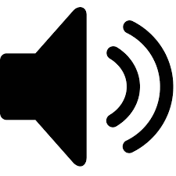 to change the volume, and to enlarge to full screen

Pronunciation

The two pronunciations of -TH-

Learn the correct pronunciation of -TH-
The pronunciation of TH in English does cause some problems. Many people do not understand the phonetic alphabet and, anyway, the sounds can be strange. Here you can watch a video and listen to examples to improve your pronunciation. Remember that the better you pronounce the better you will understand when others pronounce English words.

Pronunciation

General rules with audio files

General pronunciation
Here is a PDF file and video of the file for pronunciation. The file contains some of the most important rules for spelling and pronunciation, they are easy to remember. Pronunciation is not easy for the English language, one of the best ways to improve is to listen to different people speaking and have the audio script so that you can see the words as you hear the pronunciation. Here is a Spoken Paragraph, it comes from a scientific text. As you hold your cursor over a word you will hear it spoken. Move the cursor slowly.

Open the PDF file here

Open the video here

Spoken paragraph (live)

Spoken paragraph (PDF)

Material

Irregular verbs and more

Irregular Verbs
List of irregular verbs | PDF
Readings
A | MP3
B | MP3
C | MP3
D | MP3
E | MP3
F | MP3
G | MP3
H | MP3
K | MP3
L | MP3
M | MP3
P | MP3
R | MP3
S | MP3
T | MP3
U | MP3
W | MP3

The Imperative in Italian
Click here to read the rules in Italian (the same as in English) 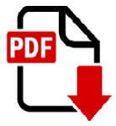

Material - Odd stuff
Here you can find lots of things that do not fit into a fixed category, for example Listenings: here there are audio and video files with tape-scripts, full and with blanks. So you could print the Blank spaces file, listen to the MP3 or watch the Video and then check your comprehension after.
There are also some PDFs concerning grammar rules, also in Italian.

Podcasts

Listen and read about words and phrases, find them in context, listen to the pronunciation, check vocabulary

tr> tr> tr> tr> tr>
To cure To treat To heal | MP3 Audio | 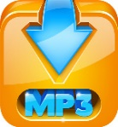
To cure To treat To heal | Full PDF
To check To control | MP3 Audio
To check To control | Full PDF
To attend - To participate | MP3 Audio
To attend - To participate | Full PDF
Very - To vary | MP3 Audio
Very - To vary | Full PDF
To breathe - Breath (n) | MP3 Audio
To breathe - Breath (n) | Full PDF
To bath - To bathe | MP3 Audio
To bath - To bathe | Full PDF
- ER - | MP3 Audio
- ER - | Full PDF

Exercises

Practice

Things to do
Here are some exercises for you: listenings, texts with blanks, and more.
Here's Oprah Winfrey's Inspirational Golden Globes Speech. She received the annual Cecil B. DeMille award for lifetime achievement. | PDF with blanks
 | PDF full script
 | MP3 Audio
 | MP4 Video
Italia's got talent! (what does this mean? Watch the video) | MP4 Video
All Tenses (check your knowledge of ALL English tenses) | MP4 Video
PDF of the video for you to print | PDF to follow video
Revision of the 4 question forms plus exercise | PDF
Answers to the exercise for 4 question forms | PDF
Revision of Simple and Continuous tenses | MP4 Video
The PDF for: Revision of Simple and Continuous tenses | PDF

Listenings

Texts and MP3 files to improve your listening

What's on this page?
Here you can find lots of different files regarding WORDS.
Confusing words
Words for medicine and science
How to write better
>
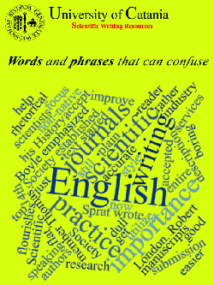
Click on the picture on the right to read the file, or listen to the MP3 audio
Uncountable nouns  Many people still write these as Plurals! | 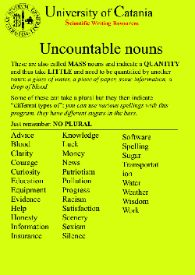
Particular  Peculiar | 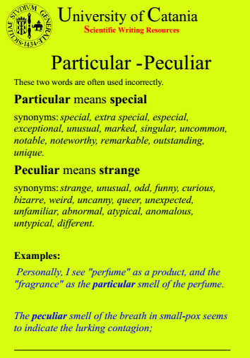
In case of  In cases of | 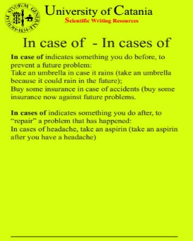
Indefinite Article | 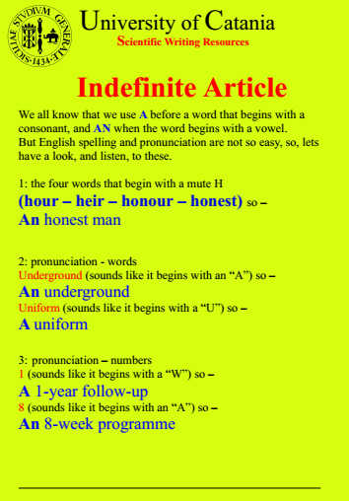
Over  During | 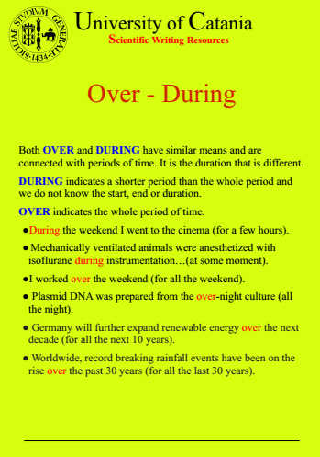
As  Like | 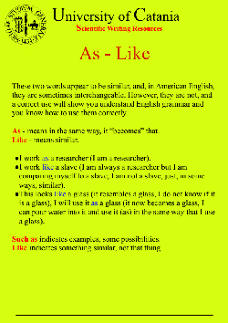
In  Into | 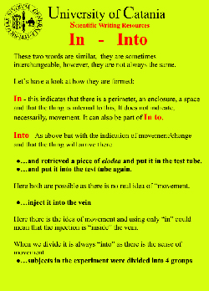
Respectively  Respective | 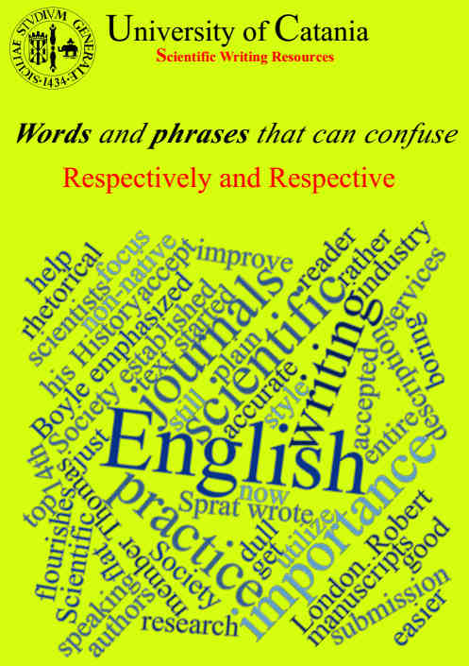
i.e. - e.g. | 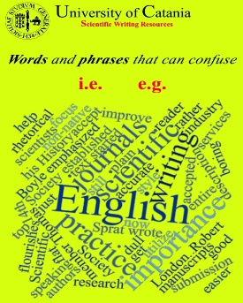
Stop to analyze - stop analyzing | 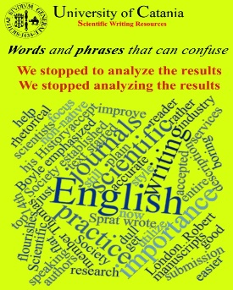
Purified of Purified from | 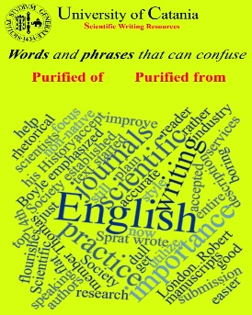
Last - Latest | 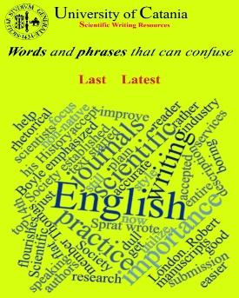
To Be - To Be Like | 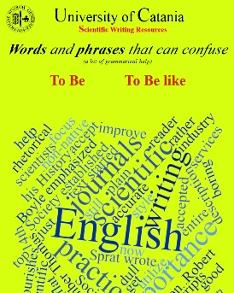
To Check - To Control | 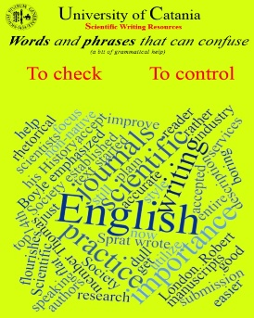
US vs UK English | 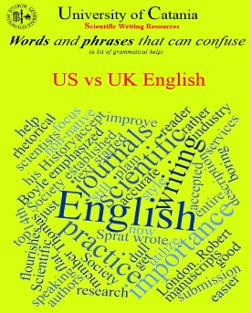
Bring - Take | 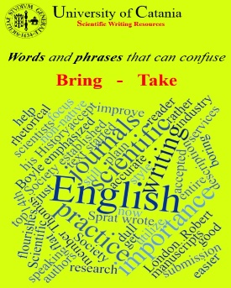
Electric - Electrical - Electronic | 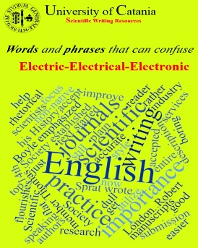
Classic - Classical | 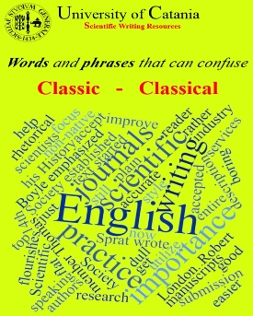
Linked with - Linked to | 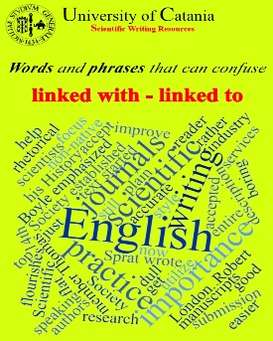

Video Listenings

Videos,texts and MP3 files to improve your listening

What's on this page?
Here you can find videos of the BBC news from London.
Download the file with BLANKS, watch and listen to the video, or just listen to the MP3 file (if available).
Check what you wrote on the FULL file
Read and listen, then, just listen
Click on the picture on the right to read the file, or listen to the MP3 audio
Name | Video | Blank | Full | MP3
BBC |  | 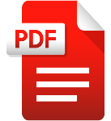
BBC

BBC
BBC 012
BBC 011
BBC 010
BBC 009
BBC 008
BBC 007
BBC 006
BBC 005
BBC 004
BBC 003
BBC 002
BBC 001

